**Software Engineering**

The term *Software Engineering* first appeared at the 1968 NATO Software Engineering Conference and was meant to provoke thought regarding what was then called the “software crisis”. It is defined as “An engineering discipline concerned with all aspects of software production from the early stages of system specification to maintaining the system after it has gone into use”. It is a systematic approach to designing, developing, operating, and maintaining a software system.

A program is just a combination of source code and object code. Programs become software only if documentation and operating procedure manuals are prepared.

There are two types of Software:

* Generic products
* Stand-alone systems are sold to any customer who wishes to buy them.
* The software developer owns the specification of what the software should do, and the developer makes decisions on software change.
* Examples are PC software such as graphics programs, CAD software, and software for specific markets.
* Customized products
* Software commissioned by a particular customer to meet their own needs.
* The customer owns the specification of what the software should do and makes software change decisions.

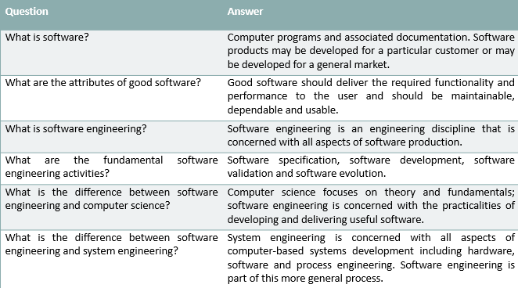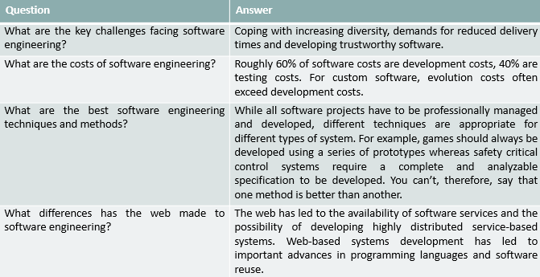Computer Science is the study of theory and fundamentals. Software Engineering studies the practicalities of software design, development, and delivery.

The software process consists of the following steps: Specification, Development (Design and programming), Validation (Checking), and Evolution (Modifications).

The software process model is the abstraction of the software development process. It consists of different views, such as the workflow view, where activities are the human actions that show the input, output, and dependencies. The dataflow view shows the transformation of information into output. The role/action view shows what work is done by people in different roles.

Software costs depend on various factors, like the process used and the type of software being developed. Roughly 60% are development costs, and 40% are testing costs. In custom software, evolution costs often exceed development costs.

CASE: Computer-Aided Software Engineering. Programs that support Requirement analysis, System modeling, Debugging, and Testing.

Attributes of good software are Performance (functional) and Quality (non-functional). Maintainability is the evolution of qualities such as testability. Dependability is reliability, safety, and security. Efficiency is the memory utilization, response, and processing times. Usability is how easy the software is to learn, how efficient it is to use, and how satisfied the users are.

Some development challenges include heterogeneity (compatibility with different computers), Delivery speeds, and trust.

LOC (Lines of Code) and PM (Person Months) are used to calculate software development productivity. For student programs, the productivity is 2.5-5 KLOC/PM. For SW organizations, it is 100-1000 LOC/PM. The significant difference occurs due to the difference between the type of work done by students and industries.

The *definition* of software (by IEEE) is given as a collection of programs, procedures, rules, and associated documentation and data. The differences between Student and Industrial Strength software are as follows:

🡺 In student software: The developer is the user. Bugs are tolerable. Good UI isn’t necessary. No documentation is required. It isn’t used critically. Reliability and robustness aren’t essential. No investment. No need for portability.

🡺 In industrial strength software: Others are the users. Bugs aren’t tolerated. UI is important. User, organization, and project require documentation. Supports important functions. Reliability and robustness are essential. Heavy investment. Portability is a crucial requirement.

Industrial strength software has better quality, costing 10 times more than student software. In **this course**, software means Industrial strength software. It is expensive. Its productivity is approximately 1000 LOC/PM, costing $3-$15 per LOC. A simple application for a business may have 20K-50K LOC. So, it costs $60K-$2.25 million for the software and $10K-$20K for the hardware.

**Driving Factors:**

Short delivery times are demanded. Cost and cycle time/schedule are fundamental driving forces. Both can be modeled by productivity, measured in output per unit effort (e.g., LOC per PM). Higher productivity leads to lower costs and cycle time.

**Quality** is another driving factor that is more challenging to define. ISO standards have six attributes for describing it.

🡪 Functionality – The capability to provide functions that meet stated and implied needs when software is used.

🡪 Reliability – The capability to provide failure-free service.

🡪 Usability – The capability to be understood, learned and used.

🡪 Efficiency – The capacity to provide appropriate performance relative to the resources used.

🡪 Maintainability – The capability to be modified to make corrections, improvements, or adaptations.

🡪 Portability – The capability to adapt to different environments without applying actions/means other than those provided in the product.

Multiple dimensions mean it is challenging to reduce Quality to a single number. Reliability is more important than usability for some projects, while some are the opposite.

**Reliability** is generally considered the main Q criterion. It is the probability of failure; it is hard to measure and approximated by no. of defects in software. Quality = No. of defects delivered / Size, where defects delivered is the no. of defects found in operation. In current practices, it is less than 1 def/KLOC.

Once the software is delivered, it enters the **maintenance** phase, where residual errors are fixed – corrective maintenance, upgrades are done – adaptive maintenance. Maintenance can take up more effort than development over the life of the software (it can even be a 20:80 ratio). Hence, maintainability is another critical quality attribute.

The software should support change, as requirements constantly change, and 40% of development may go into implementing changes.

Scalability is another crucial element in software development. Methods for solving small problems do not scale up for large problems. Two dimensions of a project are engineering and project management. For small scale, both can be done informally. For large scale, both must be formalized. The software should be able to handle large problems.

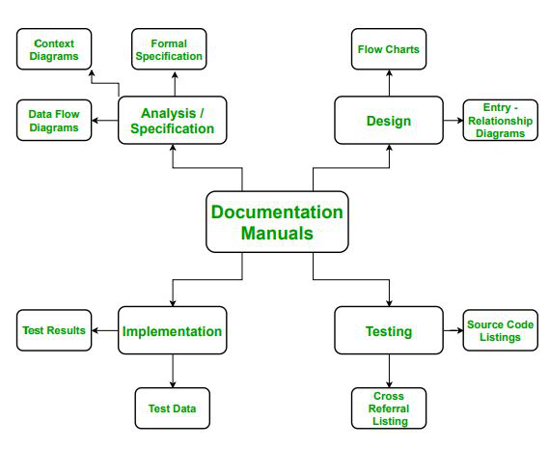**List of Operating Procedure Manuals:**

**Implementation**

**Testing**

Operating procedures have two parts, user and operational manuals. User manuals have a system overview, Beginner’s guide tutorial, and Reference guide. Operational manuals have Installation and System administrator guides.

Some terminologies:

1. Deliverables and Milestones – Deliverables are source code, user manuals, operating procedures, etc. Milestones ascertain the project’s status, such as finalizing specifications and completing design documentation.
2. Product and Process – The product is delivered to the customer. The process is how software is produced.
3. Productivity and Effort
4. Module and Software Components – An independent deliverable piece of functionality providing access to its services through interfaces.
5. Generic and Customized Software Products – Generic products are developed for everyone. Customized products are designed for particular customers.

Software is developed through stages: Requirement analysis and specification, Design, Coding, and Testing.

Error prevention is preferred over error correction in present times. Modern times require detecting errors to be as close to their point of introduction as possible.

Exploratory style is where a single programmer develops software, and Modern software development processes are done by a team. Now, errors are detected in each phase of development as opposed to only during testing. Coding is only considered a small part of program development, unlike when coding was synonymous with program development. A lot of effort and attention is being paid to requirement specifications. There is a different design phase in modern software development. It has been made systematic, and periodic reviews are carried out during all stages. More care is poured into making consistent and good-quality documentation, which makes management more effortless. Projects are being appropriately planned, with an estimation of requirements, scheduling tasks, and monitoring mechanisms. They also use CASE (Computer-Aided Software Engineering) tools.

**Software Life Cycle Model**

It is a descriptive and diagrammatic model of the software life cycle that identifies all the activities undertaken during product development. It divides the life cycle into phases and establishes an order among activities. It helps identify inconsistencies, redundancies, and omissions in the development process. It helps in developing a common understanding of activities among software developers.

Why is Life Cycle Model important?

In an exploratory model where a single programmer develops the software, he has the freedom to decide his steps like Code 🡪 Test 🡪 Design, Code 🡪 Design 🡪 Test 🡪 Change code, or Specify 🡪 Code 🡪 Design 🡪 Test.

When a team develops software, there must be an understanding among the members as to when to do what. Otherwise, the project would be a failure. In a life cycle model, entry and exit criteria are set for every phase. Only when they are satisfied is a phase considered to be complete.

Software engineering aims to produce good quality, maintainable software within a reasonable time frame and at an affordable cost. The software life cycle starts from the concept of exploration and ends at the retirement of the software. The cycle includes a requirement phase, design phase, implementation phase, test phase, installation and checkout phase, operation and maintenance phase, and finally, retirement phase.

The software life cycle model is an abstraction of a software life cycle, like classes and objects. A software life cycle model is often called a software development life cycle (SDLC).

**Software Development Life Cycles**

1. Build and Fix Model

It is a simple two-phase model and not well-defined. The first phase is to write code, and the next is to fix it. Here, fixing may be error correction or the addition of additional functionality. This model is used when a product is constructed without specifications. So, the developer builds a product that is reworked as many times as necessary to satisfy the client. This may work well on small programming exercises of 100 or 200 lines long. It is unsatisfactory for software of any reasonable cost, as code soon becomes unfixable.

1. The Waterfall Model

It is the most familiar model having five phases. These phases always occur in order and do not overlap; each phase should be completed before the next one begins.

Requirement Analysis & Specification

Integration and System Testing

Maintenance

Implementation and Unit Testing

Design

🡺 🡺 🡺 🡺

* 1. Requirement Analysis and Specification Phase:

Understanding the customer’s requirements and documenting them properly. This is done together with the customer. The output of this phase is a document known as Software Requirement Specification (SRS), written in natural language describing what the system will do without explaining how it will be done.

* 1. Design Phase:

Transforming the requirements specification to be implementable in some programming language. Software architecture is defined, and high-level design work is performed. This work is documented as Software Design Description (SDD).

* 1. Implementation and Unit Testing Phase:

Design is implemented. The code is examined and modified during testing. Small modules are tested in isolation.

* 1. Integration and System Testing Phase:

Testing how the integration of all modules is working together. A critical phase, when done correctly, will result in high-quality software, satisfied users, low maintenance costs, and more accurate and reliable results. It consumes one-third to half of the cost of a typical development project.

* 1. Operation and Maintenance Phase:

Error correction, capability enhancement, removal of obsolete capabilities, and optimization are done after the software is delivered to the customer’s site, installed, and operational. This phase preserves the value of software over time.

Problems of the Waterfall Model:

Defining all the requirements at the beginning of a project is complex and unsuitable for accommodating any change. It takes time to develop a working version of the system. It doesn’t scale up well to large projects, and real projects are rarely sequential.

1. Iterative Waterfall Model

The main difference between the standard and iterative waterfall models is the feedback paths from each phase to its preceding phases. This will make the model more usable in practical software development projects.

Feasibility Study



1. Feasibility Study:

This phase is for determining whether software development is financially and technically feasible.

This phase includes activities such as collecting information relating to data items that would be input to the system, processing required to be carried out on these data, output data needed to be produced by the system, and various constraints on development. Feedback paths allow error correction. But there is no feedback path to the Feasibility Study phase.

Advantages:

🡪 Having a feedback path supports error correction, reducing the effort and time required in the waterfall model.

Disadvantages:

🡪 All requirements must be stated before starting the development phase, as there is no scope for incorporating changes once the development phase begins.

🡪 There is no scope for intermediate delivery. The software is completely developed and tested before delivery.

🡪 Overlapping of phases is not supported. But in real projects, phases may overlap to reduce the time needed to complete the project. If testing starts only after the completion of the design phase, rather than completing the basic design and testing the partial project, it will take more time for the project completion.

🡪 This model doesn’t have any mechanism for risk handling.

🡪 The team interacts with the customer only during the requirement-gathering phase and after the project completion. These fewer customer interactions may lead to problems as the developed software may differ from the customer’s requirements.

1. Increment Process Model

It is also known as the Successive version model. A simple working system with few basic features is built that is delivered to the customer. Then many successive versions are implemented and delivered until the design is released.

Software requirements are first broken down into modules that can be incrementally constructed and delivered. As the plan is made just for the next increment and not for any long-term plan, it is easier to modify the version per the customer’s needs.

Advantages:

🡪 The core modules are tested thoroughly by the user from the beginning, reducing the chances of errors.

🡪 This model doesn’t require the customer to commit significant resources at once for the system development. It also saves the developing organization from deploying large resources and workforce for the project simultaneously.

Disadvantages:

🡪 It requires good planning and design, with well-defined module interfaces.

🡪 Total cost is high.

1. Prototyping Model

A working prototype of the system is built before the development of the existing software, with limited functional capabilities, low reliability, or inefficient performance compared to the existing software. The GUI part of the software is developed, and the user experiments with the prototype and suggests any required changes.

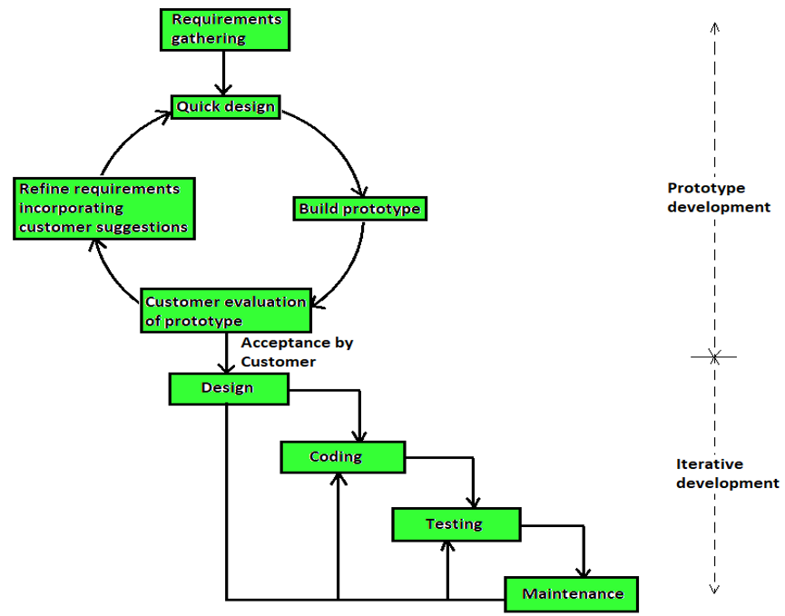When the requirements are unclear, a prototype helps examine technical issues with product development. This reduces the risk of not knowing the required development technology. This model best suits online systems and web interfaces requiring high interaction with end users. Even if it takes a while for development, this model ensures that the end users constantly work with the system and provide feedback that will be incorporated into the next iteration. This model has two major development activities – one is prototype construction, and the other is iterative waterfall-based software development.

**Prototype Development** – It starts with an initial requirements-gathering phase. A quick design is made for the prototype. It is then submitted to the customer for evaluation. The prototype is refined based on customer feedback until the customer approves of the prototype.

**Iterative Development** – Once the prototype is approved, the existing software is developed using an iterative waterfall approach. Despite the availability of a working prototype, an SRS document is needed since it is invaluable for carrying out traceability analysis, verification, and test case design during later phases.

The code for the prototype is usually discarded, but the experience gained from its development helps in the actual development process. Customer requirements are adequately defined and are resolved because of the prototype, minimizing costs due to change requests in later stages.

Advantages:

🡪 Developers and customers are in sync with each other’s expectations, helping them understand the system better.

🡪 Ideal for online systems requiring a high level of human-computer interactions.

🡪 Flexible to changes in requirements. Integration requirements are well understood.

🡪 Software requires minimal user training as users get trained using the prototype from the project’s beginning.

Disadvantages:

🡪 Cost of development can increase, while the risks are significantly less.

🡪 It may take more time to develop the software.

🡪 It is effective for projects where risks are identified before the development starts. Risks identified after the development phase starts cannot be mitigated.

1. Spiral Model

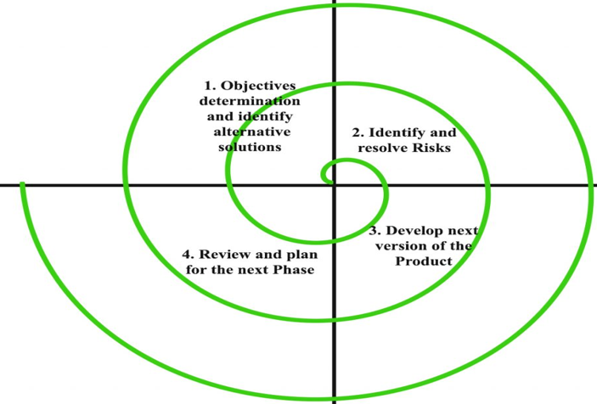This model provides support for Risk Handling. It looks like a spiral with many loops in its diagrammatic representation. The no. of loops of the spiral is unknown and can vary for each project. Each loop is called a phase in the software development process. The no. of phases can be varied depending on the project risks. The project manager determines the number of phases, so he has a vital role in developing a product using the spiral model.

**Risk** is a future uncertain event with a probability of occurrence and potential for loss. It is any adverse circumstance that might hamper the successful completion of a software project. Different types of risks are Time-related/Delivery-related Planning Risks, Budget/Financial Risks, Operational/Procedural Risks, Technical/Functional/Performance Risks, and other Unavoidable Risks. This model supports risk handling by providing the scope to build a prototype at every phase of the software development process.

The prototyping model also supports risk handling, but they must be entirely identified before the development phase. But in real-life projects, risks may occur even after the development phase starts, so the prototype model doesn’t work.

In the Spiral model, the product's features are analyzed, and the risks at that point are resolved in each phase through prototyping. Thus, this model is much more flexible compared to other SDLC models.

Each phase of the Spiral model is divided into four quadrants, as shown in the figure. Their functions are:

* Objectives determination and identifying alternative solutions

Requirements are gathered, and objectives are identified, elaborated, and analyzed at the start of every phase. Then possible alternative solutions for the phase are proposed in this quadrant.

* Identify and resolve risks.

The best out of all possible solutions is selected during the second quadrant. The risks associated with this solution are identified and resolved using the best possible strategy, and a prototype is built for this solution.

* Develop the next version of the product.

The identified features are developed and verified through testing during the third quadrant. At the end of this quadrant, the next version of the software is available.

* Review and plan for the next phase.

The customer evaluates the developed version of the software. By the end of the fourth quadrant, planning for the next phase is started.

The spiral model is called a **Meta Model** because it subsumes all other SDLC models. A single loop of the spiral represents the Iterative Waterfall model. It incorporates the stepwise approach of the Classic Waterfall model. It uses the Prototyping model by building a prototype at the start of each phase as a risk-handling technique. It can also be considered supporting the evolutionary model – the iterations along the spiral can be regarded as evolutionary levels through which the complete system is built.

Advantages:

🡪 Risk analysis and handling is a significant part of this model.

🡪 It is recommended to use the Spiral Model in large and complex projects.

Disadvantages:

🡪 It is much more complex than other SDLC models.

🡪 It is costly and not suitable for small projects.

🡪 It is too dependent on risk analysis. Without high expertise, development using this model will be a failure.

🡪 As no. of phases is unknown at the beginning of the project, time estimation is complicated.

1. RAD Model (Rapid Application Development)

IBM proposed this model in the 1980s. The crucial feature of this model is the use of powerful development tools and techniques. This model works when a project can be broken down into small modules, assigned independently to separate teams, and combined to form the final project. Each module development uses basic steps as in the waterfall model, i.e., analyzing, designing, coding, testing, etc. The time taken for the project completion is generally 60-90 days, which is much less.

This model consists of 4 primary phases: Requirements planning, User description, Construction, and Cutoff.

Requirement Planning:

It involves various techniques used in requirements elicitation like brainstorming, task and form analysis, user scenarios, FAST (Facilitated Application Development Technique), etc. It also consists of a structured plan describing the critical data, methods to obtain it, and then processing it to form the final refined model.

User Description:

This phase consists of taking user feedback to build a prototype. It includes the validation of data collected in the first phase.

Construction:

Refinement and delivery of the prototype, after using powerful automated tools to make required modifications and enhancements, and then transforming process and data models into the final working product is done in this phase.

Cutover:

All modules are tested using powerfully automated tools, followed by acceptance testing by the user. The process involves building a rapid prototype, delivering it to the customer, and taking feedback. After customer validation, SRS is developed, and the design is finalized.

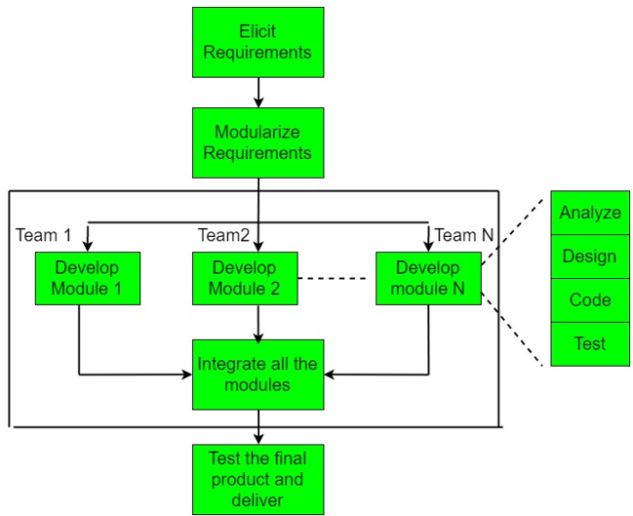Advantages:

🡪 Use of reusable components helps reduce the project’s cycle time.

🡪 It is easier to accommodate requirement changes as customer feedback is available at the initial stages.

🡪 Powerful tools increase quality, decrease time, and reduce cost as few developers are required.

🡪 The progress and development of the project can be measured through various stages.

Disadvantages:

🡪 The use of powerful tools requires highly skilled professionals and reusable components, without which it will fail.

🡪 Customer involvement is required throughout the life cycle, and the team leader should work with developers and customers to close it in time.

🡪It is not meant for projects that cannot be modularized suitably or small projects for which the cost of using automated tools may exceed the entire budget.

1. V – Model

The process executes sequentially in V-shape. It is also known as Verification and Validation model. The development of each step is directly associated with the testing phase. The next phase starts only once the previous one is completed. The two main phases of this model are development and validation. In each development phase, along with the development of the product, test case design and the plan for testing the product are carried out. The actual testing is carried out in the validation phase. This validation plan created during the development phase is carried out in the corresponding validation phase. Unlike the waterfall model, testing activities are spread throughout the life cycle.

In the validation phase, testing is conducted in each corresponding phase.

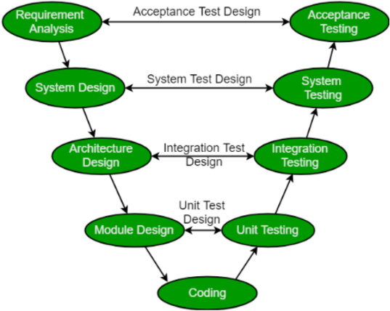**Design Phases:**

🡪Requirement Analysis – It contains detailed communication with the customer to understand their requirements and expectations. This stage is known as requirement gathering.

🡪System Design – It contains the complete hardware and communication setup for project development.

🡪Architectural Design – System design is broken into modules taking up different functionalities. Data transfer between internal modules and the outside world (other systems) is clearly understood.

🡪Module Design – The system breaks down into small modules. Detailed design of modules known as Low-Level Design (LLD) is designed.

**Testing Phases:**

🡪Unit Testing – Plans are developed in the module design phase and executed to eliminate code or unit-level bugs.

🡪Integration Testing – Modules are integrated, and the system is tested. This is performed in the architecture design phase. This test verifies the communication of modules among themselves.

🡪System Testing – Complete application is tested with its functionality, interdependency, and communication. It tests the functional and non-functional requirements of the developed application.

🡪User Acceptance Testing (UAT) – Performed in a user environment resembling a production environment. It verifies that the delivered system meets the user’s requirements and is ready for real-world use.

Advantages:

🡪Much of the testing activities are carried out parallel with the development activities, leading to a shorter testing phase and faster product development than the iterative waterfall model.

🡪Test cases are designed when the schedule pressure is not built up, so the quality is better.

🡪The test team is kept occupied throughout the development cycle, unlike only during the testing phase in the waterfall model.

🡪Testing team is associated with the project from the beginning, building a good understanding and helping test the software effectively.

Disadvantages:

It is a derivative of the classic waterfall model, inheriting most of its weaknesses.

🡪High risk and uncertainty.

🡪Not good for complex and object-oriented projects.

🡪Not suitable for projects without clear requirements and having a high risk of changing.

🡪This model does not support the overlapping of phases.

🡪It does not easily handle concurrent events.

1. Agile Software Development

It is a time-bound iterative approach that builds software incrementally from the start of the project. It is primarily designed to help a project adapt quickly to change requests. Its main aim is to facilitate quick project completion. To accomplish this task, agility is required. Agility is achieved by fitting the process to the project and removing non-essential activities for a specific project. Also, anything that wastes time and effort is avoided (documentation).

It refers to a group of development processes. These processes share some essential characteristics but have specific subtle differences. Some Agile SDLC models are Crystal, Atern, Scrum, etc.

Features:

🡪Agile projects include a customer representative on the team to get a clear understanding of customer requirements.

🡪It relies on working software development rather than comprehensive documentation.

🡪Customer requirements are incorporated in incremental software versions delivered in intervals of a few weeks.

🡪Recommended to have small team(5-9) emphasizing on efficient communication and collaborative work environment.

🡪Agile development process usually deploys Pair Programming where two programmers work together at one work-station. One does coding while the other reviews the code as it is typed. They switch their roles every hour or so.

Disadvantages:

🡪Lack of formal documents leads to confusion and misinterpretation of important decisions taken during different phases at later points of time by different team members.

🡪It becomes difficult for external experts to review design decisions without formal documents.

🡪Maintenance becomes a problem after developers disperse after the project completion.

**Software Requirement Analysis and Specifications**

🡪A condition or capability a user needs to solve a problem or achieve an objective to satisfy a contract, standard, specification, or other formally imposed documents.

🡪There are three types of software requirements: Functional, Non-Functional, and Domain.

Functional Requirements are the basic facilities demanded by the user. They must be incorporated into the system as a part of the contract.

Non-Functional Requirements are the quality constraints the system must satisfy according to the project contract. They are also called non-behavioral requirements. They deal with Security, Portability, Maintainability, Reliability, Scalability, Performance, Reusability, and Flexibility. Constraints are classified into the following types: Interface, Operating, Economic, Life Cycle (Maintainability, Portability, etc.), and Performance (Security, Response time, Storage space, etc.).

Domain requirements are characteristics of a particular category or domain of projects. The essential functions that a system of a specific domain must necessarily exhibit.

**Software Requirement Specification (SRS)**

The requirements analysis and specification phase aims to understand the customer requirements and organize them into the Software Requirements Specification (SRS) document. It is a description of a software system to be developed. It lays out functional and non-functional requirements and may include a set of use cases that describe user interactions that the software must incorporate. It is done by a few experienced members of the development team. System Analysts gather and analyze customer requirements and then write the SRS.

Once ready, it is first reviewed by the project team for understandability, consistency, unambiguity, and completeness. Later, it is given to the customer for review. After acceptance by the customer, it forms the basis for all future development activities and serves as a contract between the customer and the development organization.

To understand one’s project, it is essential to have an SRS listing their requirements and how one plans to meet them and complete the project. It helps the team identify the limitations and risks early on and plan ahead. It establishes the basis for agreement between client and developers on what the product will do. It acts as a reference for the validation of the final product. High-quality SRS reduces development costs and is a prerequisite to high-quality software.

Requirement Gathering, Analysis, and Requirement Specification are the two main activities in making the SRS. Requirement gathering involves studying the existing document, interviewing the customer, task, scenario, and form analysis.

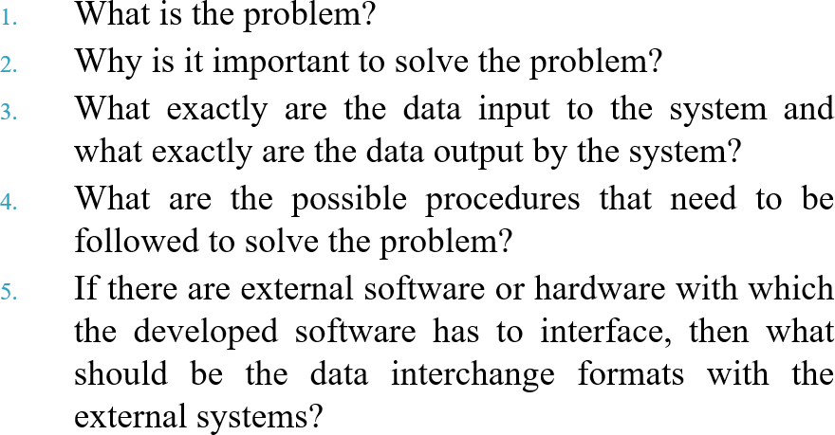The requirement analysis phase asks queries like:

During this stage, the analyst must identify and resolve three main problems: Anomaly, Inconsistency, and Incompleteness. Example of Anomaly: While gathering the requirements for a process control application, the stakeholder asks for a requirement that when the temperature becomes high, the heater should be switched off.

Desirable characteristics of an SRS: It should describe the system to be developed as a black box and specify only the externally visible behavior of the system without revealing the internal workings. For this reason, SRS is also called the black-box specification of the software being developed. Some other characteristics are that the SRS should be: Correct, Complete, Unambiguous, Verifiable, Consistent, and Ranked for importance and stability. Over-specification, Forward references, Wishful Thinking, and Noise make a bad SRS.

The components of an SRS are Functionality, Performance, Design constraints, and External interfaces.

Some of the terms used in an SRS are:

🡪Actor: A person who uses the built software.

🡪Primary actor: For whom the use case is initiated and whose satisfaction is the main objective of the use case.

🡪Scenario: A set of actions to achieve a goal.

🡪Main success scenario: If nothing fails and all steps in the scenario succeed in the interaction.

🡪Exceptional scenario: If some of the steps in the main scenario do not complete successfully.